Brock Audience View
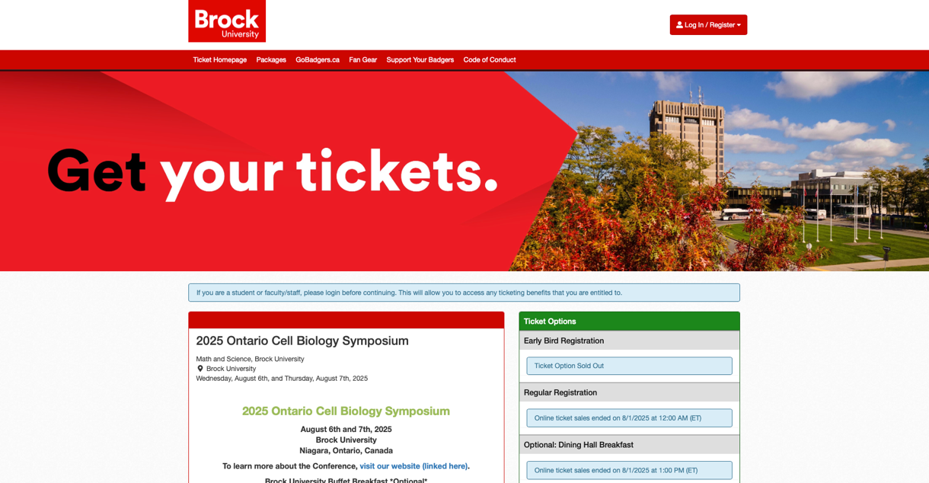
- Cannot change Brock options at the top standard setting
Header:
- OE3C and logo
  - Suggestion: Pull colours from logo and OE3C logo
Bottom Left:
- Info about the conference à Match website
- Land acknowledgements
Bottom Right:
- Registration bins and prices
  - Student: $190
  - Post Docs: $225
  - Professors: $250
    - Suggestion: Build fees into cost and no early bird special
- Coupon code: WINAFREEMEMBERSHIP (open to suggestions)
- Deadlines and extensions?
Registration:
- Have it that customers enter the information themselves and pull reports after
- Brock registrants will use their personal brock emails and externals will have to create an account

- Questions:
  - Name and pronouns
  - Dietary restrictions
  - Accessibility concerns
Add-ons:
- Banquet Tickets
- Workshops and Outings
  - Caps?
- Parking Passes
- Merch
Abstract Submission:
- Keep separate from registration portal

To populate website after:
- Discount codes for transportation

